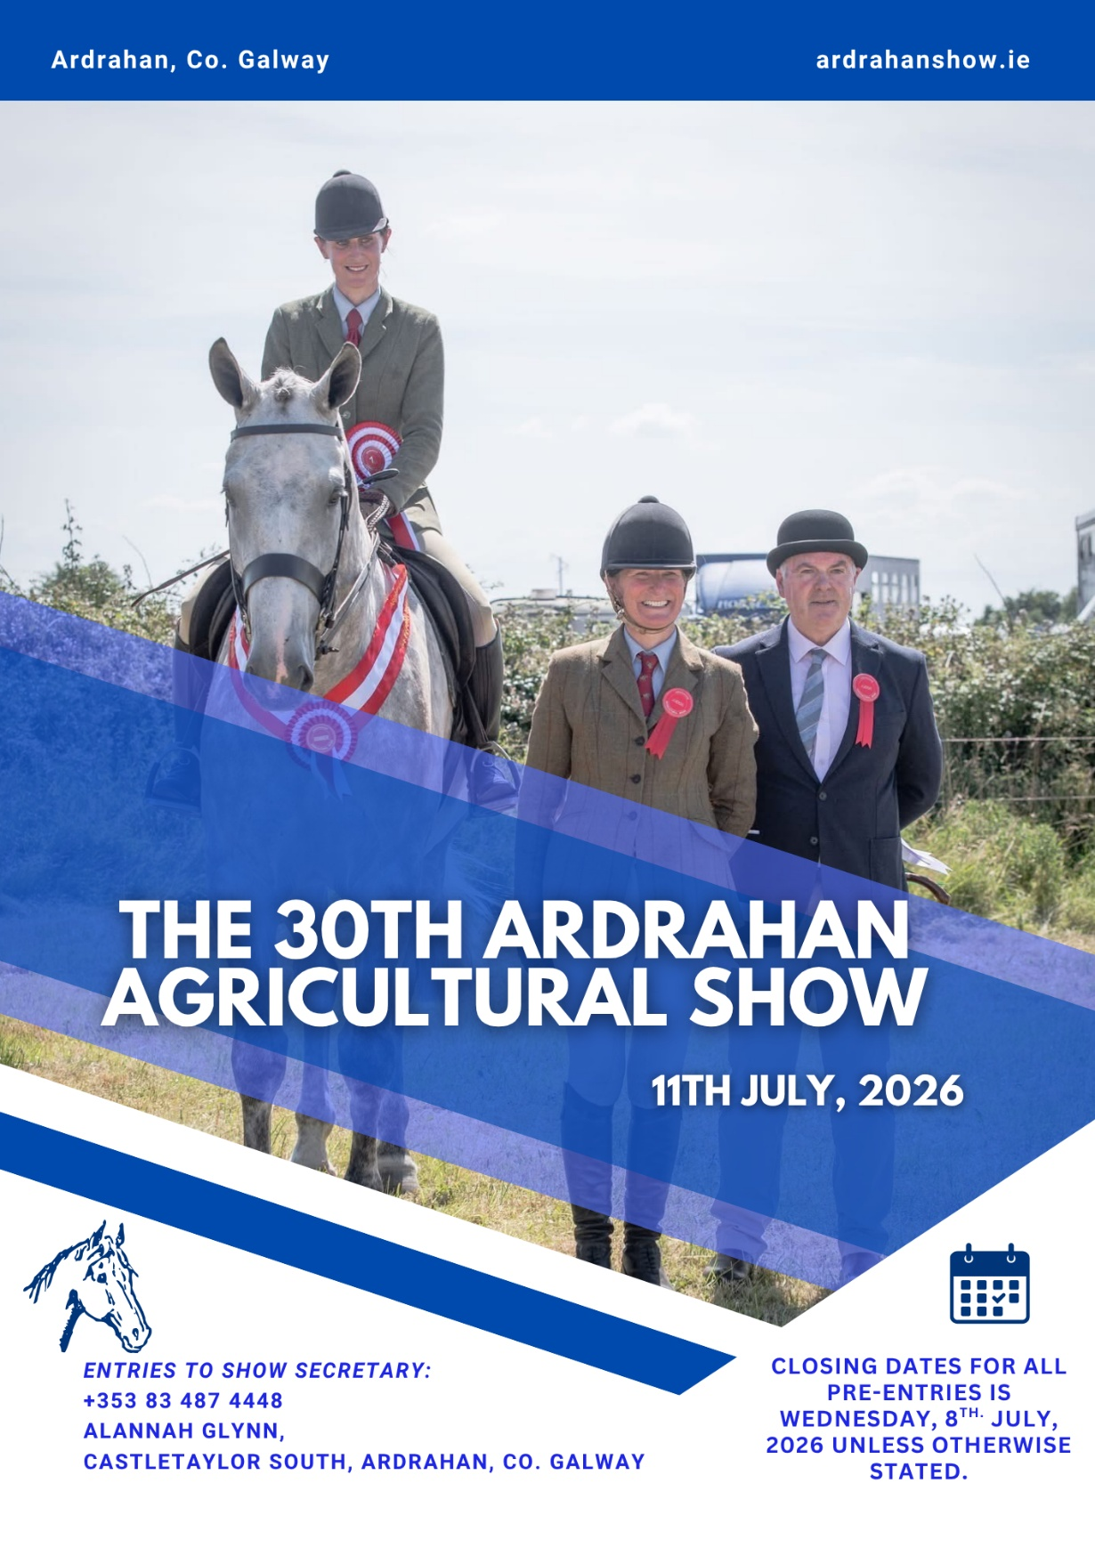

All Equine Exhibitors must have their Premises registered with the DVO and show their Equine Registration Number on their entry form.
No telephone entries. Fees must accompany all entry forms.

Member of the Irish Shows Association
Affiliated to the Irish Pony Society and Side Saddle Association of Ireland

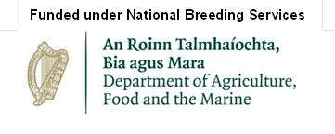

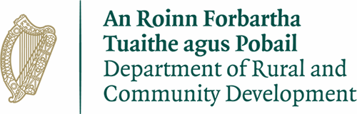
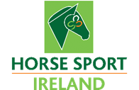
Rules of the Show
- All exhibits must be bona fide property of the Exhibitor since 1st May 2026.
- The judges’ decision as to merit shall be final and objections on other points must be lodged with the Secretary, in writing, on date of Show and must be accompanied by a fee of €50 All objections will be decided by the committee and the fee returned unless the objection is considered frivolous.
- Where age is a qualification, the committee may in any case direct an examination by the V.S. The committee shall hear any submissions by the exhibitor and shall then decide the matter and the decision shall be final.
- The term ‘committee’ in these rules means the group consisting of a Chairman, Secretary, one Treasurer, one Vice Chairman and P.R.O., or any four of them.
- The judges are empowered to withhold prizes in any class where there is not sufficient competition or merit, and furthermore no second place prize money will be paid unless there are three or more exhibits and no third place prize money will be paid unless there are five or more exhibits in the class.
- All cups and perpetual trophies won by exhibitors at the 2025 show must be returned to the Secretary, three weeks prior to the 2026 show. Each recipient must sign a form accepting responsibility for cups and trophies before same are presented at the 2026 show.
- The showgrounds open at 8.00am, judging commences at times stated in schedule.
- Entries in all Horse and Pony classes close on July 8th. 2026. The declaration on the entry form must be signed by the exhibitor and must be accompanied by the correct entry fee, otherwise the entry will not be accepted.
- Entries may not be changed on Show Day. Entries that fail to show are not entitled to refunds and no refunds will be given in the case of entries being withdrawn.
- The committee will not be responsible for loss or accident of any kind which may occur to exhibitors, exhibits, visitors, spectators, vehicles, or property of any kind.
- The committee requests exhibitors to send in their entries as early as possible.
- Should any matter arise not provided for in the purview of these rules and regulations, the same shall be referred to the Executive Committee, whose decision shall be final, from which there shall be no appeal and entries are only accepted on these conditions.
- All foals must be haltered and lead in the Show Grounds and during classes.
- In order to finance current and future development, the National Executive of the Irish Shows Association have placed a ‘Championship Fund’ levy of 5c in €1 in Horse and Pony sections. This fund will be deducted from the prize money to be paid out in these sections.
- All animals will be shown at owners’ risk. Exhibitors are advised to have their own public liability insurance up to date.
Important Notice:
Horse-riding is a dangerous sport and all competitors in Ridden Classes are strongly advised, for their own safety, to wear appropriate head gear which complies with up to date safety standards.

Rules and regulations for all Championship Qualifiers available from Show Secretary.

*Closing date of Wednesday, 8th July 2026 applies for all pre-entries unless otherwise stated. Entries received after this date or placed on the show day will be subject to an additional €5 charge per entry.
Responsibility of Exhibitors:
- Exhibitors accept that the Judge’s decision is final in all cases.
- Any abuse of Judges will not be tolerated. Where a dispute or case for complaint arises, the matter should only be dealt with under 8 below.
- Exhibitors should be familiar with the Irish Shows Association Disciplinary Policy as published on our website and annual guidebook.
- Winners of Qualifiers are themselves responsible for entering their qualifiers (or exhibits) for the final in accordance with the rules above, within one hour of qualifying.
- Winners of qualifiers will compete in the final.
- The Irish Shows Association in conjunction with the sponsors reserve the right to alter or amend the rules of the competition as may be necessary where appropriate.
- Shows and competitors must contact the ISA for details of any championships and not the sponsor involved.
- Objections must be lodged in writing with the I.S.A. representative at the show and the Show
- Secretary within half an hour following the completion of judging, together with a fee of €50, or other stated fee, which is refundable in the event of the objection being upheld.
- Any exhibitor who makes a false declaration or misrepresents a fact regarding themselves or their exhibit is liable to disqualification and/or forfeiture of any prizes awarded.
- If a qualified exhibitor does not turn up to an ISA final without giving prior notice to the ISA office or to a board member, he or she will incur a financial penalty.
Ring 1: In Hand Horses
Starting 11:00 am
*Animals entered in qualifying classes must also enter in the appropriate show class. Rules and regulations for all championship qualifiers are available from the show secretary.
Youngstock
Prize Fund: €105. Entry Fee: €20, Qualifiers: €15 (entries on show day subject to additional €5 charge per entry).
1. The Yearling Filly All Ireland Championship Qualifier.
Sponsored by S.H. Electrical & Mechanical Ltd. Final at Bridgetown Show Sunday, 26th July, 2026.
2. Yearling Colt/Gelding or Filly.
3. The Kildysart Two Year Old Filly All-Ireland Championship Qualifier
Sponsored by Clare Oil Co. Ltd., Banner Contractors Ltd. and Kildysart Show. Final at Kildysart Show Sunday, 2nd August, 2026.
4. The Red Mills Two Year Old Gelding All-Ireland Championship Qualifier.
Sponsored by Red Mills, Goresbridge. Final at Tinahely Show Monday, 3rd August, 2026.
5. Two Year Old Colt/Gelding or Filly.
6. Three Year Old Gelding or Filly.
Young Horse Championship 1st. and 2nd prize winners in Classes 2, 5, & 6.

Mares
Prize Fund: see below. Entry Fee: €20, Qualifiers: €15 (entries on show day subject to €5 charge per entry).
7. Brood Mare likely to produce a High Class Hunter.
This competition is open to animals registered in a World Breeding Federation for Sport Horses (WBFSH) studbook or a Department of Agriculture Food and The Marine (DAFM) approved studbook with recorded breeding. Prize Fund: €2,000. 1st. €600; 2nd. €450; 3rd. €300; 4th. €200; 5th. €150; 6th. €100; Breeder of Winning Mare €200.
8. Irish Draught Mare.
Open to animals, with the breed code ID, registered in The Irish Draught Horse Studbook (or a harmonised Irish Draught Studbook) with recorded breeding. Prize Fund: €2,000. 1st. €600; 2nd. €450; 3rd. €300; 4th. €200; 5th. €150; 6th. €100; Breeder of Winning Mare €200.
Classes 7 and 8 are funded by the Breeding Grant Initiative, under National Breeding Services with thanks to the Department of Agriculture, Food and the Marine, and delivered by Horse Sport Ireland’.
Mare Championship: 1st. and 2nd prize winners in classes 7 & 8.
9. The All Ireland Broodmare and Foal Team Championship Qualifier.
Final at Iverk Show Saturday, 22nd August, 2026.

Foals
Prize Fund: €75. Entry Fees: €15, Qualifiers: €15 (late entries subject to €5 charge per entry).
10. The Colt Foal All-Ireland Championship Qualifier.
Sponsored by Brian Boru Service Station. Final at Scarriff Show Sunday, 6th September, 2026.
11. Sport horse Colt Foal.
12. Sport horse Filly Foal.
13. Irish Draught Colt Foal.
14. Irish Draught Filly Foal.
Foal Championship: 1st and 2nd prize winners in classes 11 – 14.
Irish Draughts
Prize Fund: €105. Entry Fees: €20, Qualifiers: €15 (entries on show day subject to additional €5 charge per entry).
15. The Roscommon Irish Draught Yearling Filly Championship Qualifier.
Sponsored by Hannon‘s Hotel, Roscommon. Final at Roscommon Show Saturday, 15th August, 2026.
16. One and Two Year Old Irish Draught Colt/Gelding or Filly from Irish Draught Mare and by Irish Draught Sire.

Traditional Cobs
Prize Fund: €75. Entry Fees: €20 (late entries subject to €5 charge per entry).
17. Traditional Irish Cob yearling & 2 year old colt, gelding or filly.
18. Traditional Irish Cob 3 year old and over.
Traditional Cob Championship: 1st and 2nd prize winners in classes 17 & 18.

Ring 2: Ridden Horses
Starting 10:30 am
Ridden Hunters
Prize Fund: €120. Entry Fee: €20 (late entries subject to additional €5 charge per entry).
19. Lightweight Hunter, 4 years old and over.
20. Medium/Heavy weight Hunter, 4 years old and over.
21. Small Hunter, 4 years old and over.
Exceeding 148cm not exceeding 158cm.
Ridden Hunter Championship: 1st. and 2nd prize from Classes 19-21.

Side Saddle
Prize Fund: €120. Entry Fee: €20 (late entries subject to additional €5 charge per entry).
- A Side Saddle Ireland rosette will be presented to the 4 highest placed members in the class. A Best Rider rosette will be presented to the ‘Best Rider’ among the members.
- A ‘Best Turned Out’ rosette sponsored by Carr & Day & Martin will be awarded to the best turned out member combination in the class.
- Members may gain points towards our new National Side Saddle Championship League by competing in this class- please see www.ssaireland.com for the league rules.
22. Ladies Side Saddle Class, affiliated to Side Saddle Ireland:
To be ridden side saddle by ladies in hunting costume. The horses shall be judged on the basis of elegant appearance, perfect manners and ability to give the judge a smooth ride. Riders must be aged 16 years or over on the 1st of January of the current year on horses exceeding 153cm.
23. Junior Side Saddle Class, affiliated to Side Saddle Ireland:
To be ridden side saddle by riders under 18 on 1st January on ponies not exceeding 153cm. The class shall be judged on manners, conformation, way of going, and rider’s ability. Riders must wear an approved harnessed hat.
Side Saddle Championship – 1st and 2nd prize winners in classes 22 and 23.

24. The All Ireland Ridden Hunter 2026
Sponsored by Ardrahan Show Society & Associates
PRIZE FUND: €3,500.
Direct entry to Ardrahan Show Secretary: Alannah Glynn, Castletaylor South, Ardrahan, Co. Galway, by Wednesday, 8th July – Entry Fee €30.
Rules and Conditions:
- This Competition is open to Mares and Geldings 4 years old and over registered in a World Breeding Federation for Sport Horses (WBFSH) Studbook or a Department of Agriculture Food and the Marine (DAFM) approved Studbook with recorded breeding to be shown under saddle.
- Exhibitors must have the Animal`s Passport available for inspection at Ardrahan Show.
- The Judges may ride each horse in all paces on either or both reins.
- The Judges will assess the conformation and movement of each horse in hand.
These rules should be read in conjunction with the I.S.A. rules.
Prizes: 1st. €500; 2nd. €400; 3rd. €300; 4th. €250; 5th. €200; 6th. €150; Best Irish Draught €200; Best 4 year old €200; Breeder of the Winner €200; All other competitors €100. A prize will be presented for the combination of best turned out Horse and Rider.
This competition is limited to the first 20 entries. No late entries will be accepted in this class.
For information on accommodation or stabling contact +353 83 487 4448

Ridden Horses
Prize Fund: €120. Entry Fee: €20 (late entries subject to additional €5 charge per entry).
25. Irish Draught Mare/Gelding, 4 years old and over.
26. Racehorse to Riding Horse, 4 years old and over.
27. Riding Horse, 4 years old and over.
28. Ridden Horse confined to Riding Club Members
(Name of Club to be submitted with entry). Entry Fee €10. Prizes in kind.
29. Ridden Cob, 4 years old and over.
Ridden Horse Championship: 1st and 2nd prize winners in classes 25 - 29.
Ring 3: Ridden/In Hand Ponies
Starting: 10:00 am.
Show Hunter Ponies (IPS)
Prize Fund: €75. Entry Fee: €15 (late entries subject to additional €5 charge per entry).
30. Open and Novice 133cm Show Hunter Pony
Over 123cms but not exceeding 133cms. Riders under 14 years on 1st January, 2026.
31. Open and Novice 143cm Show Hunter Pony
Over 133cms but, not exceeding 143cms. Riders under 17 years on 1st January, 2026.
32. Open and Novice 153cm Show Hunter Pony
Over 143cms but, not exceeding 153cms. Riders under 20 years on 1st January, 2026.
33. Open and Novice Intermediate Show Hunter Pony,
Over 148cm but not exceeding 158cms. Riders under 25 years on 1st January, 2026.
Show Hunter Championship – 1st and 2nd prize in classes 30 – 33.

Mini Ponies
Prizes in kind. Entry Fee - €10 (late entries subject to additional €5 charge per entry).
34. Open SH/SP Lead Rein, Ponies not exceeding 123cms
Rider under 8 years on 1st January, 2026. Rosettes to all competitors.
35. Open SH/SP First Ridden, Ponies not exceeding 123cms
Rider under 10 years on 1st January, 2026. Rosettes to all competitors.
Mini Championship – 1st and 2nd prize in classes 34 and 35.

Family Ponies
Prizes in kind. Entry Fee - €10 (late entries subject to additional €5 charge per entry).
36. Family Pony Lead Rein. Mare or gelding not exceeding 138cms.
Rider under 10 years on 1st January, 2026. Rosettes to all competitors.
37. Pony any age shown in-hand.
38. Young Handlers Class, Ponies 4 years old and over.
To be shown in-hand by children aged 7 to 13 years on 1st January, 2026. Handlers must wear correct dress.
39. Young Handlers Class, Ponies 4 years old and over
To be shown in-hand by children aged 14 to 18 years on 1st January, 2026. Handlers must wear correct dress.
*Classes 38 and 39 will be judged on the ability of the handler to present and show the pony to best advantage. Ponies entered in these classes must also be entered in relevant classes at the show.

In Hand Connemaras
Prize Fund: €75. Entry Fee - €15 (late entries subject to additional €5 charge per entry).
40. Registered Connemara Yearling and Two Year Old Colt/Gelding.
41. Registered Connemara Yearling and Two Year Old Filly.
42. Registered Connemara Pony Stallion.
43. Registered Connemara Pony Gelding, 3 Years old and over.
44. Registered Connemara Pony Mare, 3 and 4 years old with/without foal at foot.
45. Registered Connemara Pony Mare, 5 to 8 years old.
46. Registered Connemara Pony Mare, 9 years old and over.
47. Foal out of a Registered Connemara Mare and by a Registered Connemara Stallion.
In Hand Connemara Pony Championship - 1st and 2nd prize in classes 40 - 47.

Ridden Connemara Ponies
Prize Fund: €75. Entry Fee - €15 (late entries subject to additional €5 charge per entry).
48. Registered Connemara mare/gelding 4 or 5 years old, under saddle.
49. Registered Connemara mare/gelding 6 years old and over, under saddle.

Ring 4 A/B: Working Hunter
Starting 9:00 am.
Working Hunter Horses
Prize Fund: €120. Entry Fee: €20 (late entries subject to additional €5 charge per entry).
50. WH Horse. Max height of fences – 80cm.
51. WH Horse. Max height of fences – 90cm.
52. WH Horse. Max height of fences – 1.00m.
Working Hunter Horse Championship - 1st and 2nd prize in classes 50, 51 and 52.

Working Hunter Ponies (IPS)
Prize Fund: €75. Entry Fee: €15 (late entries subject to additional €5 charge per entry).
53. Open and Novice 153 cm working hunter pony, mare or gelding.
Over 143cm not exceeding 153cm. Rider under 20 years on 1st January, 2026.
54. Open and Novice 143cm working hunter pony
Over 133cm not exceeding 143cm. Riders under 17 years on 1st January, 2026
55. Open and Novice 133cm working hunter pony, mare or gelding.
Over 123cm not exceeding 133cm Riders under 14 years on 1st January, 2026.
Working Hunter Pony Championship - 1st and 2nd prize in classes 53, 54, & 55.

56. Open working hunter lead rein pony, mare or gelding. Entry fee €10.
Over 123cm. Riders under 8 years on 1st January, 2026. Rosettes to all competitors.
57. Newcomers Working Hunter. Entry fee: €10.
For ponies that have not won a working hunter prize. No other working hunter entries allowed on the day. Max fence height: 18”. Rosettes for all competitors.

Connemara Pony Working Hunter
Prize Fund: €75. Entry Fee: €15 (entries on show day subject to additional €5 charge per entry).
58. Working Hunter for registered Connemara Pony 4 years old and over (U16)
To be ridden by rider under 16 on 1st January, 2026.
59. Working Hunter for Registered Connemara Pony 4 years old and over (O16)
To be ridden by rider over 16 on 1st January, 2026.
60. All Ireland Ridden Registered Connemara Performance Pony Championship Qualifier
Final at Oughterard Show Sunday, 30th August, 2026.
*Animals entered in qualifying classes must also enter in the appropriate show class. Rules and regulations for all championship qualifiers are available from the show secretary.
Dog Show
Starting 12:30 pm.
Entry fee: €5/€3 for qualifier classes
61. The Dog Safe Fence Connacht Championship (Open to all Breeds) Qualifier Sponsored by Tony Keane, Ballina Kennels, Co. Mayo. Prize Fund: €1,200.
Rules and Conditions:
- This competition is open to any breed of dog.
- Two dogs to qualify at each show.
- Entries in this championship may compete in any other dog class at Bonniconlon Show.
- All dogs must enter the ring without a rosette.
Final at Bonniconlon Show Monday, 3rd August, 2026.
62. The Gain All Ireland Championship sponsored by Gain Pet Nutrition Qualifier. Prize Fund: €500.
Rules and Conditions:
- Toy or miniature dog any breed to be handled by a child under 15 years.
- Large dog any breed to be handled by a teenager or an adult.
- One dog from each class to qualify.
- Dogs in final not eligible to compete in other classes at Clonaslee Show.
Final at Clonaslee Show Sunday 13th September, 2026.
63. The All Ireland Irish Native Breed Dog Championship Qualifier sponsored by Ballinasloe Dog Owner. Prize Fund: €400.
Rules and Conditions: This competition is confined to Irish Native Breeds any variety – dog/bitch.
Which are as follows:
- Glen of Imaal Terrier
- Irish Red Setter
- Irish Red and White Setter
- Irish Soft Coated Wheaten Terrier
- Irish Terrier
- Irish Water Spaniel
- Irish Wolfhound
- Kerry Beagle
- Kerry Blue
- Two dogs to qualify from each qualifying show.
- Entries in this championship cannot compete in any other dog classes at Ballinasloe Show. These rules should be read in conjunction with the ISA rules.
Final at Ballinasloe Show on Saturday, 26th September, 2026
64. A.V. Puppy dog or bitch 6-12 months old
65. A.V. Jack Russell Terrier.
66. A.V. Terrier excluding Jack Russell.
67. A.V. Pointers and Setters (German, Pointer, Irish/English/Red Setter, etc.)
68. A.V. Labradors and Retrievers.
69. A.V. Hound (Basset, Beagle, Dashound, Wolfhound, Rhodesian Ridgeback, etc)
70. A.V. Collie (Rough/Border Collie, Shetland Sheepdog, etc).
71. Working Group (GSD, Boxer, Dane, Doberman, Rottweiler, St. Bernard, etc)
72. Utility Group (Tibetan Terrier, Poodle, Schnauzer, Akita, Spitz, etc)
73. Toy Group (Bichon Frise, Pekingese, Poodle, Cavalier, Pug, Pomeranian, etc.)
74. Spaniel.
75. Junior Handling (aged under 15 years).
76. Ladies Handling.
77. Gentleman Handling.
Champion Handler (Drawn from Winners of Classes 72, 73, & 74).
Champion Dog and Reserve Champion Dog of the Show.
Only dogs placed 1st in classes 62 -71 (Breed and Group Classes) are eligible to compete for Champion Dog and Reserve Champion Dog of the Show. Dogs placed in the Novelty Classes are not eligible to compete for Show Champion or Reserve Champion of the Show. The Judges’ decision is final.
78) The Dog I would like to take home.
79) Dog in Fancy Dress.

Discipline

The Irish Shows Association expects and will insist upon appropriate behaviour from all Exhibitors and others participating in any of the activities at our Member Shows and will not tolerate inappropriate behaviour.
Inappropriate behaviour shall include but not be limited to the following:
- Profanity, coarse or vulgar language or gestures towards judges, exhibitors or other Show officials
- Harassment or bullying, including using words or actions that threaten, intimidate or undermine
- judges or other officials before, during or following Member Show activities.
- Failure to follow rules and/or obey instructions.
- Abusing any animal
Disciplinary Procedure:
Complaints of misconduct against an Exhibitor, Spectator or other participant at an affiliated Show or any event organised by The Irish Shows Association, or alleged breaches of the rules and standing orders of The Irish Shows Association, shall all be investigated and adjudicated upon by a Disciplinary Committee appointed by the Board of the Irish Shows Association. All complaints must be submitted in writing and must be signed by all parties submitting the complaint. The Disciplinary Committee shall seek to ensure the existence of consistent, effective, fair, and transparent complaint procedures and shall act in accordance with natural and constitutional justice. Hearings of all committees shall be confidential and held in private, unless the committee decides otherwise.

NOTES

