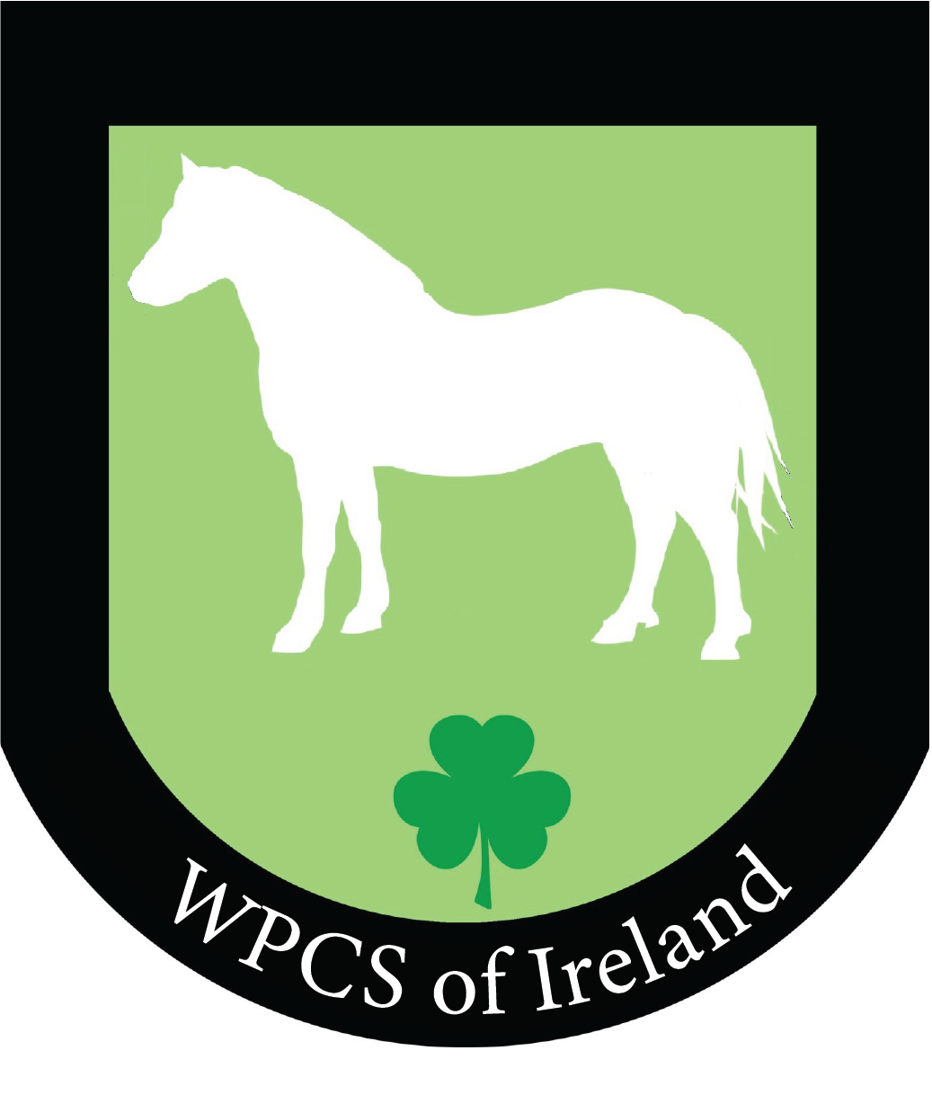
Foal Show Schedule 2026
Tipperary Equestrian Centre, By kind permission of Tomas Ryan
On Monday 26th October 2026 at 11.00am
Judge. Jeff Grace
For classes 4-8 ponies must be shown plaited. All Foals must be leading independently. Mares can accompany if not weaned. Entry form to state breeding and registration. Also if for sale and also if that is the case a description of performance potential can be added to additional information.
For all Pure bred breed classes i.e. Welsh, Connemara, foals must be passported with the appropriate breed society. Entries; www.itsplainsailing.com/org/ipsshows
Prize fund; €20, €10, €5.
Foal to mature exceeding 148cms
Class 1. Foal to make a potential Intermediate.
Class 2. Coloured Cob/Traditional Foal
Class 3. Sport Horse Foal
Horse/Cob to exceed 148cms Supreme Horse Foal Championship Classes 1-3
Class 4 Coloured pony foal. Sponsored by Tyrellspass Pony Stud.
Class 5. Show Hunter Pony Sponsored by Kilbride Equestrian
Class 6. Show Pony sponsored by Barossa Pony Stud
Class 7. Part bred.( Must be registered with appropriate breed society )
Class 8. Foal to make a 123cms Mini Pony . ( SP/SHP/M&M) Please present as Breed/Type. Sire and Dam not to exceed 128cms Sponsored by Ballinacarrig Stud
Plaited Pony Championship Classes 4-8
If less than 3 entries per class the following will be amalgamated with highest placed colt/filly getting their respective rosette.
Pure Bred Welsh Classes
Class 9. Pure bred Welsh section A Colt Sponsored by Kilbride Equestrian
Class 10. Pure bred Section A Filly Sponsored Barretts Agriculture
Class 11. Pure bred Welsh Section B Colt Sponsored by Solar on the Move
Class 12 Pure bred Welsh Section B Filly Sponsored by Araglen Ponies
Class 13. Pure bred Welsh Section C & D Colt
Class 14. Purebred Welsh Section C & D filly
WPCS of Ireland Pure Bred Champion colt Champion € 20 Reserve €10
WPCS of Ireland Pure Bred Champion Filly Champion €20 Reserve €10
WPCS of Ireland Studbook Overall Welsh Champion Highest Placed ponies from Pure Bred Colt and Pure Bred Filly Registered with WPCS of Ireland Studbook Champion €150 Res €50 plus the Paulank Trophy.
Class 15. Connemara colt
Class 16. Connemara filly.
Overall Connemara Championship
Josie O’Brien Trophy Overall Supreme Pony Foal; ( Champion & Reserve in Plaited, WPCS of Ireland Colt & Filly, Overall Connemara)
Sponsored by Red Mills .. Champion €60 Reserve €40
SP/SHP or M & M to present as per category. Should entries suffice these will be split
17. Broodmare Class
18. Yearling SP/SHP or M & M colt, Filly or Gelding
19. 2 & 3 yr old Colt, Filly or Gelding.
Youngstock Championship Classes 18 & 19
Entry fee; €20.00 on itsplainsailing Entries will close 23rd October to allow for Catalogue production.
Late Entries after closing date €25 on its plain sailing up to 26th October …catalogue entry not guaranteed
Sponsorship link will also be on its plain sailing.
No ponies or foals can be led by anyone under the age of 16 in any class. Unless over 14 and prior permission is sought from IPS.
Non Members to pay a daily membership

